EGM6611: Continuum Mechanics Final Paper

Characterizing the Mechanical Response of Human Skin
Using the Ogden Hyperelastic Material Model

Jackson Sammartino
April 23, 2025

- Introduction
Material of Interest
The skin is the largest organ of the human body, with a wide range of functions including protection against environmental dangers, temperature regulation, and tactile sensation. Three layers of tissue compose the skin- the epidermis (outermost), dermis, and hypodermis. The dermis constitutes approximately 90% of the skin’s thickness and contains the protein collagen, which is responsible for the strength and elasticity of the skin [1]. Modeling the mechanics of human skin is challenging due to its anisotropic, hyperelastic, and viscoelastic nature- still, it is essential for understanding and improving medical treatment, cosmetics, etc. [2], [3].
Material Properties of Interest
Used extensively in nonlinear solid mechanics, the Ogden model is a hyperelastic material model which can capture the large-deformation behavior of rubbery and biological materials, for example. The model is formulated based on a summed strain energy function W, consisting of 3 principal stretches λ, and material constants μ_{i} and α_{i} which must be determined through experimental testing and curve fitting [4]. More detail will follow on how constitutive stress-strain relationships are derived from the Ogden model.
$$W=\sum_{i=1}^{n}{\frac{μ_{i}}{α_{i}}\left({λ_{1}}^{α_{i}}+{λ_{2}}^{α_{i}}+{λ_{3}}^{α_{i}}-3\right)}$$
Two Case Studies
The first source for this paper is “Modeling the Mechanical Response of In Vivo Human Skin Under a Rich Set of Deformations” by Cormac Flynn, Andrew Taberner, and Poul Nielsen (2011, 110 citations on Google Scholar), hereby referred to as “Source 1” [5]. Source 2 for this paper is “Implementation and validation of constitutive relations for human dermis mechanical response” by Alessandra Aldieri et al. (2018, 23 citations on Google Scholar) [6]. Both studies examine the mechanical properties of human skin using physical experimentation and finite element modeling, developing constitutive relations based on the Ogden hyperelastic model.

- Testing Procedures
Source One
The authors of Source 1 emphasize studying the skin in vivo to capture the effect of pretension, using their own data from a micro-robot (Figure 1) applied to the upper and lower forearm of 21 live volunteers [7]. The probe of the robot was moved along three axes, while an arrangement of force sensors measured the reaction force with an uncertainty of 6 mN. Varying the in-plane angle from 0° to 180°, with an out-of-plane angle of 0°, 45°, or 90°, and displacements ranging from 1.0-1.8 mm, a large dataset of displacement-force data was obtained [7]. This dataset certainly included a wide variety of stress states (uniaxial, biaxial, simple shear, etc.) Several experimental measures were taken to ensure accurate and consistent data: testing both the top and bottom of the forearm, testing both the right and left arms, repetition on different days, and subtracting off energy losses calculated during loading/unloading [7].
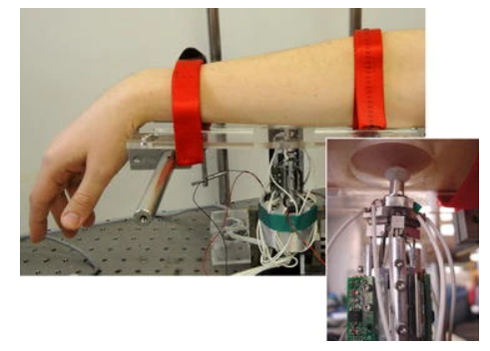
Figure 1: Experimental setup of micro-robot used in Source 1 to operate on live skin [5].
To verify their data, Source 1 created a finite element model (FEM) in Abaqus (Figure 2). Using a circular area analogous to the test region of skin in Figure 1 and shell elements (SR4) of thickness 1.5 mm (typical skin thickness), they ran a variety of simulations using the material parameters determined in their live experiments [7].
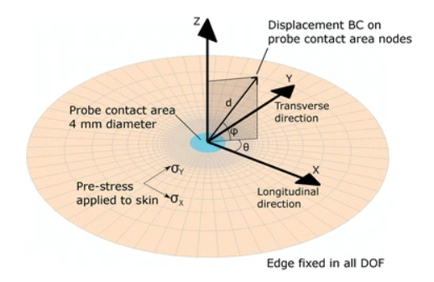
Figure 2: Abaqus finite element model used in Source 1 [5].
Source Two
In contrast to Source 1, Source 2 did not perform live testing. Four specimens of tissue were excised from the lower back area of human donors, then trimmed, chemically treated, and cleaned for testing. Equibiaxial data was collected from a universal testing machine (UTM) with two load directions as shown in Figure 3 [8].
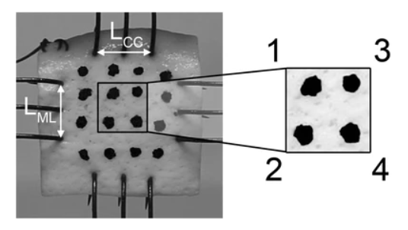
Figure 3: Biaxial experimental setup of skin sample in UTM used in Source 2 [6].
Similarly to Source 1, Source 2 verified their data through finite element simulation in Abaqus (plane stress CPS4-type elements) on a model with the same geometry, loading, boundary conditions, etc. as the physical test [6].

- Constitutive Equations
Both sources investigated the suitability of the Ogden model for the n = 1 and n = 2 cases, with Source 1 also factoring in a hydrostatic pressure term (p is the hydrostatic pressure and J is ratio of deformed to undeformed volume) [5].
$$W=\sum_{i=1}^{n}{\frac{μ_{i}}{α_{i}}\left({λ_{1}}^{α_{i}}+{λ_{2}}^{α_{i}}+{λ_{3}}^{α_{i}}-3\right)}-p\left(J-1\right)$$
For an incompressible (J = 1) material with n = 1, the Ogden model simplifies to:
$$W=\frac{μ_{1}}{α_{1}}\left({λ_{1}}^{α_{1}}+{λ_{2}}^{α_{1}}+{λ_{3}}^{α_{1}}-3\right)$$
This shows that, for the Ogden n = 1 model, only two material constants are needed: μ₁ and α₁. Principal Cauchy stresses σ_{i} were then calculated by differentiating W with respect to λ_{i} – note that Einstein/summation/index notation is not implied in the following equation.
$$σ_{i}=λ_{i}\frac{∂W}{∂λ_{i}}=λ_{i}\left(μ_{1}{λ_{i}}^{α_{1}-1}\right)=μ_{1}{λ_{i}}^{α_{1}}$$
In full 3D tensor form, where F is the deformation gradient tensor and C is the right Cauchy-Green tensor F^{T}∙F:
$$σ=\frac{2}{J}F∙\left(\frac{∂W}{∂C}\right)∙F^{T}$$
$$where \frac{∂W}{∂C}=μ_{1}C^{\frac{α_{1}-2}{2}} and J=\det\left(F\right)$$

- Results
Table I below summarizes the numerical results of Sources 1 and 2, calculated through curve fitting/optimization procedures [5], [6].
Table I: Results for Material Constants
Source | μ₁ | α₁ | Ratio μ₁/α₁
1 [5] | 13.14 kPa | 632.62 | 0.02077 kPa
2 [6] | 47.0 kPa | 210 | 0.224 kPa

It is important to note that Source 2 (four specimens tested) reported values of μ₁ ranging from 27.4 to 91.4 kPa and α₁ from 146 to 372, giving ratios of 0.188 to 0.246 kPa.

- Comparison and Discussion
Overview
First and foremost, the results of the two studies differ greatly, with the ratio of μ₁ to α₁ for Source 2 being about 9 times greater than for Source 1 (Table I). Based on their FEM, Source 1 states that the Ogden model (n = 1) was accurate at predicting the in-plane response of the live forearm skin, i.e. plane stress; however, it was quite poor at predicting out-of-plane behavior, with 30.3% error overall [5]. Source 2 expresses confidence in its findings, but acknowledges the wide range of results across their four specimens, further stating a larger experimental dataset is necessary [6].
Possible Reasons for Differences
Generally speaking, a high μ₁ value indicates that stress increases proportionally faster than strain, while a high α₁ indicates the opposite. Based on these relationships between stress, strain energy density, and material properties μ₁ and α₁, as well as from the differences in the two papers’ methodologies, several explanations for the large numerical differences can be proposed: A) The primary discrepancy is that Source 1 tested on live skin, while Source 2 used extracted samples. Live skin, attached to the whole body, is much more elastic than dead skin which has been removed from the body, thus explaining the much lower μ₁ value and higher α₁ value. In other words, the live skin experienced significantly less stress, compared to dead skin, for the same values of strain. B) The dead skin was treated with chemicals and cleaned before testing, which seems to introduce impurity into the specimen. C) From Figure 3, the hook-like setup used to attach the sample to the load cells may have introduced discontinuities and/or stress concentrators into the specimen, compared to the more continuous and pure live specimen in Figure 1. D) Source 1 mentioned the average age of their subjects was 29.4 years, with standard deviation of 8.0 years, but Source 2 does not discuss this potentially confounding variable [5]. Older skin may be more hard and less elastic than younger skin. E) Source 2 only tested four samples in one loading mode (equibiaxial), compared to 84 samples (21 volunteers, both arms, both sides of each arm, with multiple repetitions for some subjects) and a variety of loading modes for Source 1. Source 2 simply may not have enough data to produce reliable results. Perhaps reasons A) and E) are most significant for explaining the large differences in the reported numbers, and why Source 1 may be generally a more reliable study.
Improvements
Despite its experimental soundness, Source 1 does mention a 30.3% error for out-of-plane or normal mechanical responses [5]. Using the Ogden model for n = 2 halved this error, likely because the tangential or in-plane response is dominated by the i = 1 terms, while the i = 2 terms more accurately capture large out-of-plane deformation [5]. Despite a slight increase in complexity, the improved accuracy of the Ogden n = 2 model gives it preference over the simplified n = 1 version. As previously mentioned regarding Source 2, a more robust dataset with more skin samples, stress states, etc. is essential [6].

- References
[1] Cleveland Clinic, “Skin: Overview and Anatomy,” online website, October 2021.
[2] A. Chanda, V. Unnikrishnan, Z. Flynn, K. Lackey, “Experimental study on tissue phantoms to understand the effect of injury and suturing on human skin mechanical properties,” Proceedings of the Institution of Mechanical Engineers, Part H: Journal of Engineering in Medicine, Volume 231, Issue 1, December 2016.
[3] S. Luebberding, N. Krueger, M. Kerscher, “Mechanical properties of human skin in vivo: a comparative evaluation in 300 men and women,” Skin Research & Technology, Volume 20, Issue 2, July 2013.
[4] N. Kim, “Chapter 3: FEA for Nonlinear Elastic Problems,” class notes, course EGM6352, University of Florida, Spring 2025.
[5] C. Flynn, A. Taberner, P. Nielsen, “Modeling the Mechanical Response of In Vivo Human Skin Under a Rich Set of Deformations,” Annals of Biomedical Engineering, Volume 39, pages 1935-1946, March 2011.
[6] A. Aldieri et al., “Implementation and validation of constitutive relations for human dermis mechanical response,” Medical & Biological Engineering & Computing, Volume 56, pages 2083-2093, May 2018.
[7] C. Flynn, A. Taberner, P. Nielsen, “Measurement of the force–displacement response of in vivo human skin under a rich set of deformations,” Medical Engineering & Physics, Volume 33, Issue 5, pages 610-619, June 2011.
[8] M. Terzini et al., “EQUI-BIAXIAL TESTS FOR MECHANICAL CHARACTERIZATION OF HUMAN ACELLULAR DERMAL MATRICES THROUGH A CUSTOM-MADE BIAXIAL FIXTURE,” WIT Transactions on Engineering Sciences, Volume 116, pages 391-400, 2017.

